
Volume: 17 Issue: 2 Summer 2011 Chapter of the Gran Sport Club of America; 625 Pine Point Circle; Valdosta, GA 31602 912-244-0577

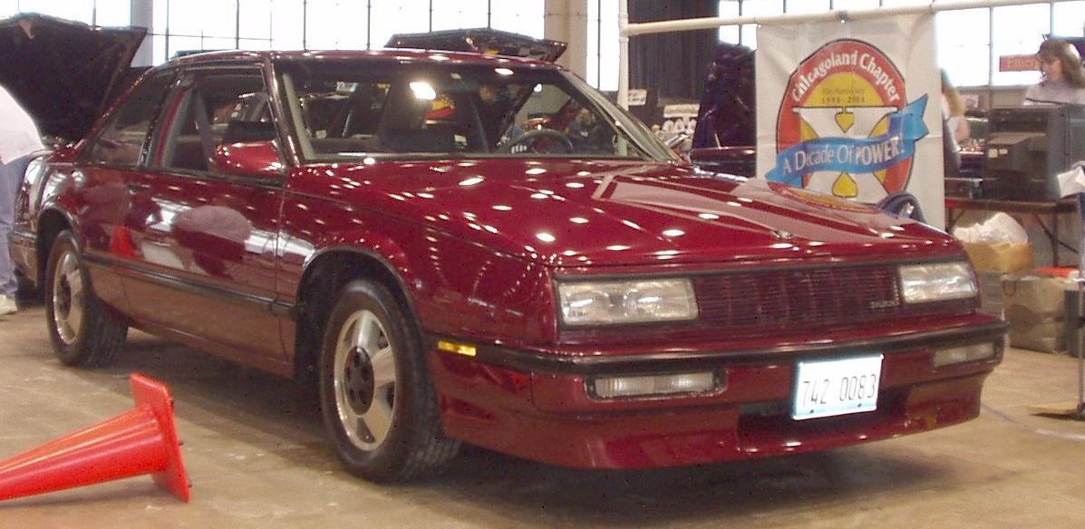
Bill Grupp’s LeSabre T-Tyoe

Many of our members have seen Bill’s front wheel drive LeSabre from past car shows or drag racing. There is quite a history to this car in the evolution There have actually been two identical LeSabres over the years.
The first car was purchased in 1994 from a dealer with lots of miles on it. In the commute to work the miles continued to pile up until it had 250,000 miles showing with the drive train getting tired. In 1999 John Spina came up with a bunch of 1998 Supercharged 3800 engines, one of which Bill purchased. The engine sat on the floor his his garage for a year and a half, while Bill searched out information to stuff into the LeSabre. At this time only about a handful of guys had attempted the transformation. Thank goodness the Pontiac GTP guys were also there tinkering with these engines as well.
In 2001 Merrilee purchased a new car, so Bill used her old one for commuter duty for about seven months while the transformation was underway. The 4T40 was pulled out and a 4T65 HD transmission from a junkyard in Woodstock was installed. Axles (half shafts) were a hybrid of what would bolt onto the transmission and what would bolt to the car’s hubs. That Woodstock junkyard got to be a familiar place as the rest of the wiring harness, computer and many sensors were collected.
The wiring manual for the car the 1998 Supercharged 3800 would have been installed in as well as Bill’s LeSabre were obtained and the puzzle of how to combine the two wiring harnesses to produce a working car commenced.
One major obstacle was the motor mounts that continued to break after the installation. Being a performance oriented guy Bill also added high lift rockers and a smaller pulley on the supercharger for more boost as we all know is a good thing.
By 2004 with a lot of daily commuting the original LeSabre was getting a little tired. From Bill’s other cars we know he could have Continued on page 3

Opinions expressed in this publication are not necessarily those of the GS Club of America, the Chicagoland Chapter of the GSCA, or any of the officers of these automotive enthusiast clubs.
Chapter Volunteers |  |  |  |  | Member’s Change of Address  Chicagoland members who move are requested to notify our membership chairman before the next newsletter mailing. We do not want you to miss a single edition of your newsletter. Please notify us of e-mail address changes as soon as you change providers.  Membership Renewal  Please check the label on your newsletter. If your membership is up in January, June will be your last newsletter. Obtain an application from the website or past issue, and mail to 4010 Raymond Avenue, Brookfield, IL 60513, along with a check for $20 made out to “CCGSCA.” Please don’t let your membership lapse, for too long.  Volunteers for the Chapter  Contact Bob Nunes if you are interested in helping our Chapter continue exchange ideas, gathering local car show and cruise night information or plan activities for our members. Fresh ideas are needed to keep the Club exciting. Distributing the work among many volunteers makes it easy for all. The tasks do not take much of your time, and you will always have plenty of help, while hopefully having fun.  Upcoming Events  Sep 11 – CCGSCA Race #5 - Byron Dragway  Sep 16 – Cruise Geo’s Grill 7090 West 79th St., Burbank  Sep 23 & 24 East Coast Buick Regionals – Cecil, MD  Sep 25 - Marquardt BOPC Car Show, Barrington, IL  Oct 2 - CCGSCA Race #6 “The Finals” – Union Grove  Oct 8 – BOP Race at Cordova Dragway  Oct 9 – Morris Lyons Club Car Show – Morris, IL  Oct 15- Ford vs. Buick Shootout – Noble, OK  Oct 19-22 - GSCA Nationals Bowling Green, KY  Nov 12 – CCGSCA Meeting at VPN in Addison, IL  2012  Jan 28 – CCGSCA Holiday Party – Countryside, IL  May 2 – 5: Turbobuick.com Nationals Burlington, NC  Jun 15 – 17 Buick Race Day – Norwalk, OH
Director ~ | Loyd Bonecutter | 708-485-8477
 | loydb@chicagolandbuick.org
Co-Director / ~ | Steve Russo | 815-795-4737
Gran Sport | s.russo@mchsi.com  .
Co-Director / ~ | Mark Holda | 630-747-7652
Turbo Regal | M.Holda@comcast.net
Activities ~ | Paul Brelie | 224-484-8057
 | ELATED3@aol.com
Race Chairman | Joe Garcia
 | jrg3517@comcast.net
Treasurer ~ | Bill Grupp
 | jackbot@yahoo.com
Secretary ~ | Barb Holda | 708-243-7280
 | Metaz_56@comcast.net
Membership ~ | Shari Bonecutter | 708-485-8477
 | sharib@chicagolandbuick.org
Graphic Artist ~ | Paul Vilser paulvilser@sbcglobal.net
 | Beth Andrews draena710@comcast.net
Publisher ~ | Loyd Bonecutter | 708-485-8477
 | loydb@chicagolandbuick.org
Advertising ~ | Beth Andrews | 847-845-7342
 | draena710@comcast.net
4th of July Show | Steve Russo | 815-795-4737
 | STEVEGS1@aol.com
Midwest Challenge | Loyd Bonecutter | 708-485-8477
 | loydb@chicagolandbuick.org
Cruise Chairman | Chris Gatch | 773-776-4794
 | cgatch@sbcglobal.net
Volunteers ~ | Bob Nunes |  | 630-310-6662
 | Rich George |  | 630-551-3120
Membership Policy & Dues
The Chicagoland Chapter of the Buick GSCA is open to all Buick enthusiasts and owners of Buick powered cars. Membership is $20 per year, and includes a quarterly newsletter and much more. Apply online at the chapter web site or send dues with check made out to CCGSCA with membership form to:
Shari Bonecutter – Membership Chairman
Chicagoland Chapter GSCA
4010 Raymond Avenue
Brookfield, IL 60513-1846

Chapter Web Page
http://www.chicagolandbuick.org

Continued from Page 1 restored this car quite easily. This time Bill managed to find an identical optioned red T-Type in Pittsburgh with no rust for less than what a total strip, repair rust areas and repaint would have cost, so Merrilee and Bill flew to Pittsburg and drove home red LeSabre number 2. That trip included a cab ride to the former owner’s residence to pick up the car and drive to where he worked to chinch the deal.
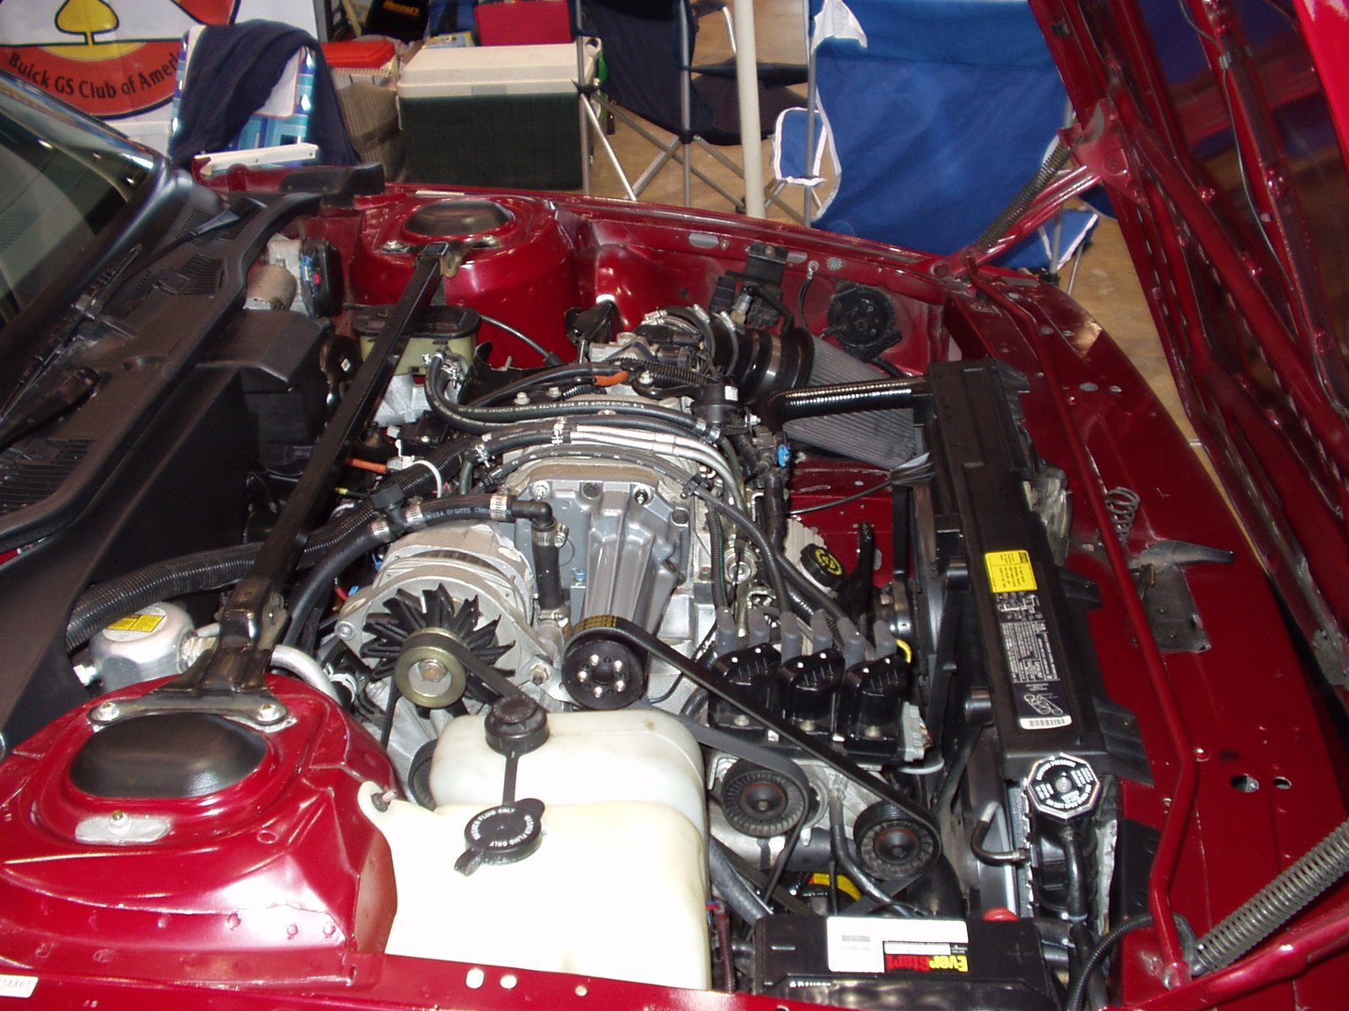
Over the long thanksgiving weekend in 2004, the engines were swapped. The old car with the Pittsburg engine was ready for the commute on Monday, giving Bill additional time to work out some details such as a better solution for the motor mounts and using Bonneville half shafts, instead of the hybrid solution.
This was also time to install the air to water intercooler under the intake manifold, replace the stock cam with a performance oriented unit, and eventually replace the tired aluminized steel exhaust system the Fair Muffler in Countryside installed with a three inch mandrel bent stainless steel system from Modern Muscle in Oswego where we held our tech session last spring.
This car had not been to the drag strip much in the past four years as Bill had the Green GS for that now, but he did take this car to the BPG Horsepower National for the T-party as it is a LeSabre T-Type. While at the event he had an opportunity to run it down the track. In the heat with fairly stick street tires he did manage to trap at 100 mph in this daily driver with 2.8 inch pulled on the supercharger. This is quite good as the car lacks a posi-traction differential, and the size of the front tires are limited.
This is definitely one fine example of Bill’s ingenuity and love for our beloved Buicks.

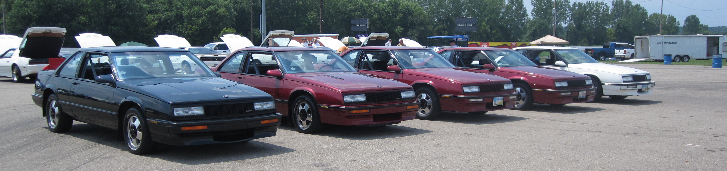
The five LeSabre T-Types at the 2011 BPG Horsepower National. Bill’s was the only one Supercharged.

Please, take a look at your mailing label it has your renewal date

Director’s Garage Loyd Bonecutter
Another summer of Buick Motorsport activities has flown past us already this year, but there is more left this fall. Opportunities to show off your car are the Marquardt BOP show, the Cordova Dragway BOP, the GSCA Nationals in Bowling Green, KY and of course our November meeting at VFN in Addison, IL. As the days grow shorter and weather cools these should be comfortable events for us.
The 15th Annual Midwest Buick Challenge had the best weather since we have moved the event to Osceola. Just a perfect weekend. The winners of the races are as follows:
Saturday:
Front Wheel Drive Class
Winner Rich George
TSM Winner Tim LeMay
Runner Up Walt Judy
THS Winner David Day
Runner Up Karl Wolcott
BCO Winner Pete Van Tholen
Runner Up Ken Miller
Buick Open Winner Dave Kolicki
Runner Up Troy McDonald
Ladies Race Winner Roberta Vasilow
Runner Up Amy Makley
Sunday:
PRO out in first round:
Darryl Sigourney, Kenny Miller, Roberta Vasilow, Dave Leonhart, Carl Creque
Street out in the first round
Ann McNew, Dave Kolicki, Paul Brelie
Quick Eight Winner Jim Dotson
Runner Up Lawrence Clark
Unfortunately the winners of the car show were not posted by the time this was written so those of you who are wondering please look in the website.
For those of you who came out to support our event we thank you. We have a challenge from our friends in Michigan who continue to win a lot of our sponsor’s prize money. Chicagoland racers need to come out in force to regain our Chapter’s sponsored event.
Speaking of our sponsors, please take a look at the list for the Midwest Buick Challenge included in this newsletter. Please thank them when you call for goods and services. They really appreciate the feedback.
For those of you who have been attending or following the standings in the Chicagoland Drag Race series, none of the races have been rained out to date. We had one race at Great Lakes that many did not attend as it continued to rain south of the Border, as the dragstrip dried up and the racing commenced. We have a handful of racers within striking distance, but Paul Brelie is predicting his winning the bragging rights as well as accumulated prize money. The Turbo Regals were dominant until the September 11th race when the semi-finals was a V8 Buick sweep. This is one series to watch. Make sure you thank Joe Garcia for all his efforts at keeping this series of racing interesting. It takes a lot of work.
Sorry for the lateness of this newsletter. This came too close to the Midwest Buick Challenge, that dominates Shari and my time prior to the event, and we needed some time to decompress immediately after. We are trying to have the Midwest Buick Challenge the same weekend next year so have to preplan a little better.
Have a great fall season and hope to see you at an event
Congratulations to Rich Diaz on the birth of his son

Take a look at the Club Membership Discount Rally Insurance is offering, give Ellen or Lars a copy of your membership card when renewing your classic car insurance.

We will need car show judges for Friday’s Car Show at the GSCA Nationals. Please volunteer

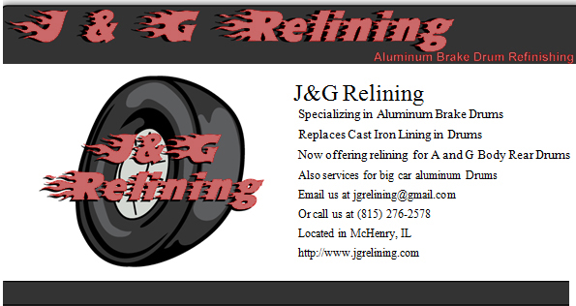

Call Don Booker with your G or A body aluminum rear brake drum needs. The stopping power for your racer will be enhanced, plus the reduced rotating mass where it counts

Shari’s Scribbling Shari Bonecutter
Hi Everyone! This is going out late, as I’m sure you can tell. I’m so sorry about that. All I can say is that I should not have Loyd and I have a deadline so close to the Midwest Challenge – there’s ‘way too much stuff going on! So pleas bear with us!
It’s been quite a summer, what with the heat and all! Then all the storms and power outages. Paul Brelie had lightning strike a tree close to the house and it caused all kinds of problems. Beth and Dana had no power for at least 3 days – I think Bill and Merrilea had the same problem. We had it go out the night before we were heading to the BPG near Columbus, OH. Fortunately for us it was only out for about 19 hours. We’re going to be better prepared in the future , with a bigger generator! We don’t have it so bad, I guess – at least we don’t have a well that depends on electricity to pump water! I’m hoping we’re all done with that for the year!
This summer was busy with all the events mentioned in the previous newsletter. Loyd and I enjoyed the Fly In/Cruise IN at Pekin Airport, in Pekin, IL. This was a first time event for these folks, and they did very well! Club members Brian Erps and Dave Woodmancy helped 100 show cars park, and directed the spectators quite handily! It was a great show, guys!
The Drive Inn night had our usual crowd with a few extra – maybe a dozen or so cars at the drive-inn itself. We did get to see Cars 2; this was great planning, Chris! We were still able to park together even though the place was packed. Maybe we’ll try to do one this fall in October or something – keep your eyes on the club website for any announcements!
The 4th of July Car Show was great, as well! There were about 480 registered cars in the show, with quite a few just driving in, looking around, and leaving. As per usual, it was hot, hot hot! The air conditioned building really felt good, with lots of space to just sit and chill. Food and drink were available for a price, which all got donated to the Local 150 Food Bank. There were door prizes galore, goody bags, silent auctions, and raffle – if you left empty handed, you had to have been asleep when they called your number! I want to thank Steve Russo for all the hard work he put in, to make this as seamless as possible for our club members to work with the Union. He did a lot of the background work, as did Frank Jackowiak. Members Beth, Dana and Liam Andrews, Paul and Linda Brelie, Chris Gatch, Barb and Mark Holda, Bob and Carol Nunes, Bob’s sister Carol, Martha LaMantia, Dave and Flo Woodmancy, Dave Anderson – you all worked your butts off for this event, and Loyd and I truly thank you for your hard work!
Most of the summer was spent either at races, cruise nights, or out of town Buick Events. Norwalk was awesome, as usual. The BPG event near Columbus was hot as usual but also very cool as it was a T-Type and Turbo Trans-Am reunion. I’ve never seen so many White Turbo-Trans Ams in one place before. The party at the host hotel was as much fun as usual, great people, great racing, and I love seeing our out-of -town friends!
Then came the Midwest Buick Challenge – oh what fun that was! We had probably our best weather on record, with absolutely no rain for a change! We had a nice attendance from the Indiana chapter at the Simonton Lake Drive Inn Friday night, until the mosquitos drove us back to the hotel. We had good attendance Saturday, the car count was down but that was the story for most of the events this summer. No accidents, no major break-downs, but I heard of a lot of trailers having flats to and fro the event. The pulled pork supper went well, with about 65 folks in attendance. There was so much food that we had a re-run on Sunday, and still brought home a bunch. Our sponsors were most generous for this year. We had $3,300 to give back to the racers! If you have an opportunity to buy something from them, please do. They really helped us out this year! We could not have pulled this event off without Beth and Dana Andrews, Paul and Linda Brelie, Barb and Mark Holda, Bob and Carol Nunes, Steve and Candy Smith from the IN chapter, Tammy Fry for the jello shots (;-) – I’m sure I’m forgetting someone! The Mustang Boys cruised through near the hotel Saturday night and shot off an impressive firework display – very nice of them! I want to thank all that attended, too. We need more of you all to come next year!
Member News: I’m hoping we don’t keep this trend going, as it’s very sad. Our condolences go to the Stasiaks for the passing of Liz’s brother-in-law; Dan Weiland’s father passed away, too. Cindy Garcia’s brother passed away, as did Ed Phiffer’s father-in-law. Larry Farneda’s father passed away, too. And lastly, our sympathies go to Paul and Linda Brelie on the passing of his mother. All of you have been in our thoughts and prayers.
Welcome to the following new members: Ann McNew, Oakley, MI; David Levine, Hamlet, IN; Kenny Miller, Charlotte, MI; Darryl Sigourney, Climax, MI; and John Turrentine, Crest Hill, IL. Welcome Back to Jason Pote, Woodridge, IL; Brandan F. Quasthoff, Des Plaines, IL and Jon Samuel, Palatine, IL. Thanks for joining!
And this just in – Rich Diaz and his wife had their first born on 8/9/11 – a son named Alexander Richard, who came in at 8.1 pounds and 19.5” long. Congrats!
This is the time of year where mostly we’re winding down to the last few races, along with the B-O-P race at Cordova, IL. The B-O-P race is in October, and should be a nice drive to the Mississippi – hopefully lots of fall colors! We can always use more Buicks at this race so if you’re so inclined, please join us. And if you get a chance, thank Joe Garcia for his hard work in setting up the club races, and keeping them running smoothly. He’s done a great job!
The GS Nats are in October, too. We’ll be there selling tee shirts, at the chapter tent. We can always use more judges for the car show. Please stop by and say hi – maybe even volunteer for judging? I’m hoping for as nice weather as we had last year, too.
We’re still trying to get a tech session for November – we’ll have one ready by the time this is ready to send out. We will have nothing scheduled for December, then start all over again in January 2012. I know the Christmas party will be in January, and we’ll be starting the tech sessions that month, too. Stay tuned to the December newsletter!
Well, today is Labor Day and the weather is very cool, about 64* here in Brookfield. I’ll take this over the 90*+ days anytime! I hope you all spent your weekend with loved ones, enjoying yourself!

Classifieds
For sale:
1986 Buick Regal Limited: 124k miles, 3rd owner. No rust. 307 V8. Cold a/c. Full power. Excellent condition. Have all maintenance records since I bought car 9 years ago. Too much to list. No snow or salt past 18 years. $4,000 Ron 815-342-5457
GN Parts : Buick t-type dash plaque 60.00 bucks, Grand National Dash Plaque 80.00 bucks, 4 GN stock chrome wheels with newer tires 750.00, Lower black windshield trim piece 30.00, GN passenger side seat complete manual tracks everything 100.00 bucks. Will trade some of these parts for some 60 pounders with a matching TT chip or a MAF translator with an LT1 MAF. Thanks. Josh Number is 815-988-7669

87 regal hood and trunk lid: 87 standard regal hood - metal is in excellent shape- no rust- paint faded- good for a hood to put a scoop on- $15 or a 12pack of good imported beer.
87 rear deck lid- no spoiler- metal in excellent shape- no rust-paint faded- $15 or a 12pack of good imported beer
Located in Darien apancner@hotmail.com

some 66 GS parts for sale: Doors for post car, include good glass and window regulators. $200 each
Deck lid $200.
Above parts are from an Arizona car. Car has great passenger area and trunk floors.
3 inch chrome moly drive shaft set up with muncie 4 speed front yoke and 1330 rear yoke included. $225. Email cacmanjr@aol.com if interested.

BF Goodrich Radial TA 295/50/15: Brand new, ordered online because I couldn't find them locally. Once I got them, they didn't fit my 69 GS w/o cutting the inner quarter lip. I didn't want to go that route and took them off right away. These have ZERO miles on them! $250. Clete @773-354-3026

69 fiberglass bumper: I have the rear fiberglass bumper for a 69 skylark. I took this off of my 69 skylark and put the metal one back on before I sold it. It comes with the reverse light but not the tail lights. It is really lightweight. It was pulled from a drag car so it has the NHRA cut off switch hole drilled through it. It is dark grey now but could stand to be sprayed again for sure. $60 Clete @ 773-354-3026
Parts for sale – you make an offer! – Rick Scheri – 815-224-4090 or 815-228-6877 or rkscheri@yahoo.com
Mostly ’72 parts – some interchangeable with ’70-’71.
’72 speedometer – 90,000+ miles, flat face
’72 tachometer – flat face; ’72 park, neutral, drive – flat face
’72 side marker
Dash bezel, Dash vent
Front turn signal assembly
Headlight bucket
Headlight bezel
Turn signal switch + wires
Perfect Skylark Hood – Antique Gold
Hood nose piece – all pins, some pits;
Hood insulation – used
2 perfect ’72 rocker moldings – Skylark
Good core support – very, very little rust
4 new tires on 14” GS rims – rechromed
4 ’72 center caps
Front bumper brackets; Front & back ’71 GS bumpers – good shape
Front ’72 rechromed bumper – perfect
Side mirror – chrome – manual
’72 service manual – mint
350 fan shroud – has been repaired
’72 air cleaner cover – primered
’72 convertible interior – new in box, Saddle color, front bench + backseat + boot
Complete 455
1936 Buick radio
2 AC Delco radios – 1 AM-FM, 1 AM only
2 Quadri-Jet carburetors
’71 Riviera radiator
’71 Riviera hub caps
’72 Skylark crank handles

Wanted to buy:

looking for 455 exhaust headers
I have a GS and the passenger side headers leak. I'm looking for a set. Thx, Clete 773-354-3026

