

Volume 9 Issue 4 Winter 2003 Chapter of the Gran Sport Club of America; 625 Pine Point Circle; Valdosta, GA 31602 912-244-0577

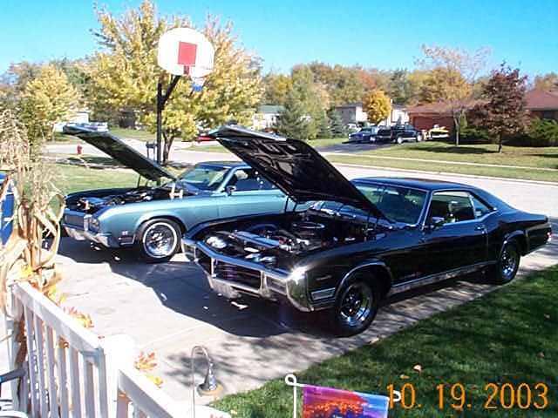
Two Brothers - Common Interest

This is a little story about 2 brothers that had a common like of cars. My brother, Dave, is the owner of an original 1970 Riviera GS. Dave purchased the car from our Grandmother in 1974. The car had 15,000 miles on it. Dave took the car apart on the advise of a old friend with the intentions of restoring the car. Well life went on and between collage and working the original teal mist grey Riviera sat.
Ten tears later incomes the crazy younger brother Chris. I always loved the car because I could remember watching Dave come around the corner…give a devilish smile and do a 50 ft. hole shot and take off. I remember sitting in the car for years (Dave never knew, sorry brother) because it was at our mom’s house. One day Dave brought his friend Bob Sikora over and they were pushing the car out of the garage. I asked what was going on and Dave was ready to repaint the car and rebuild the engine. Well Bob talked Dave into restoring and doing a full frame off. The car took about 7 months to restore. Every day it was worked on. Every part, bracket, nut and bolt was plated or repainted. Asked to help by Dave, I fell in love with the car and Buicks myself. Our uncle has an Electra 225 Convertible (black with red interior) with dual quads and 20,000 original miles on it. Dave’s car was so beautiful and rare because there where 3 types of 70 Rivs. One had a side spear and full skirts; one was mini skirts and a vinyl top, and one with full skirts and a vinyl top. Dave’s never had a vinyl top or a side spear. The car came that way from Ray Buick in Chicago. The car now has 30,000 miles on it.
I started as out painting cars in 1985 because of Dave’s car and have never looked back. I currently work for Dupont Automotive Refinishing and wanted a car of my own. I painted hundreds of show cars so it was time. Dave was constantly telling my wife Kellie about “letting Chris show off what he can do” she finally caved in and Dave and I went to go look at a 69 Riviera GS in Palos Hills. The car was all there and had minimal rust. The original owner took great care of her car and had every receipt from 1969! I took the car to my friends at Kennedy’s Auto Body in Braidwood where I could work on the car for the next year. Ron, John, Steve, Pat and Kenny are the best. I rebuilt the car to drive and enjoy. I knew I could get the car shiny but I wanted it to be straight. So I blocked, and blocked the car and it came out great. (Go to page 3)

Opinions expressed in this publication are not necessarily those of the GS Club of America, the Chicagoland Chapter of the GSCA, or any of the officers of these clubs.
Chapter Volunteers |  |  |  |  | Chapter Web Page  http://www.chicagolandbuick.org  Webkeeper - Loyd Bonecutter 708-485-4851  Please check the chapter web site for the latest information.  Member’s Change of Address  Chicagoland members who move are requested to notify our membership chairman before the next newsletter mailing. We would not want you to miss a single edition of your newsletter. Please notify us of e-mail address changes as soon as you change providers.  Membership Renewal  Please check the label on your newsletter. If your membership was up in June, this will be your last newsletter. We should have an application in this issue – handy for you to fill out and mail to 4010 Raymond Avenue, Brookfield, IL 60513. Please send this along with a check for $20 made out to “CCGSCA.” Please don’t let your membership lapse!  Nomination of officers  Please note the various functions needed to operate this Chapter. Please contact Bob Nunes if you are interested in helping our Chapter continue our pursuit of excellent Buick Motorsport activities for our members. It is very important to have fresh ideas introduced into the operation of the Club.  Upcoming Events  Dec. 6 Christmas Party at Brookfield VFW Hall.  Dec. 25 Great joy opening the boxes of Buick parts  Jan. 11 Meeting at Casper Electronics  Jan 17 & 18 World Drag Expo – Pheasant Run  Jan. 18 VCCA Swap at Bill Jacobs Chevorlet  Jan 30 thru Feb. 1 World of wheels  Feb. 8 Meeting at Brad Crowe’s shop  Mar. 7 ANS annual Chili Cookoff & meeting  Mar 28. BOPC Swap at DuPage Co. Fairgrounds  April 10 Meeting and Dyno Day – ATR in Joilet.  April 30 thru May 2 Buick Race day at Norwalk  May 18 thru May 22 GS Nationals at Bowling Green
Director | Loyd Bonecutter | 708-485-8477
 | loydb@chicagolandbuick.org
Co-Director / GS | Steve Russo | 708-873-0468
 | STEVEGS1@aol.com
Co-Director / | Mark Holda | 708-442-5580
Turbo Regals | m.holda@attbi.com
Activities | Paul Brelie | 708-452-8225
 | ELATED3@aol.com
Race Chairman | Paul DuBois | 815-758-6591
 | Tweeked6@aol.com
Treasurer | Steve Jones | 815-248-3075
 | jonesddj@Stateline-ISP.com
Secretary | Barb Pedrak | 708-442-5580
 | metaz_56@attbi.com
Membership | Shari Bonecutter | 708-485-8477
 | sharib@chicagolandbuick.org
Graphic Artist | Paul Vilser | 847-991-5556
 | pvilser@vc.fortdearborn.com
Publisher | Position Vacant
Advertising | Loyd Bonecutter
 | loydb@chicagolandbuick.org
Photographer & | Frank Jackowiak | 630-655-0598
4th of July Show | frank@itpphoto.com
Midwest Challenge | Bernie Rekus | 660-668-4480
Chairman | rekus@earthlink.net
Cruise Chairman | Chris Gatch | 773-776-4794
 | cgatch@sbcglobal.net
Volunteers | Bob Nunes |  | 847-455-7796
 | Jason Stasiak |  | 815-442-3263
 | Bob Ward |  | 847-854-3941
 | Bob Hill |  | 708-499-6491
 | Brian Campbell |  | 847-289-1205

Membership Policy & Dues
The Chicagoland Chapter of the Buick GSCA is open to all Buick enthusiasts and owners of Buick powered cars. Membership is $20 per year, and includes a quarterly newsletter and much more. Apply online at the chapter web site or send dues with check made out to CCGSCA with membership form to:

Shari Bonecutter – Membership Chairman
Chicagoland Chapter GSCA
4010 Raymond Avenue
Brookfield, IL 60513-1846

The car was green but my mom and uncle always told me that nothing looks better then a black car. So it’s black.
Dave’s engine is a .030 455 SF code with fully ported Greg Gessler heads, intake, and exhaust manifolds. Dave’s car is stock appearing and has a Club cam H230-245. The carb is a custom 820 cfm Rochester and a 2-¼ inch custom exhaust by the late Jim Bratcher. The car also has an MSD 6A. The car has a high performance electric fuel pump in the tank like the OEM. Desktop dyno shows the car to be about 440 hp. It’s definitely the beauty of the group like Dave.
Now the beast…I was always the “devil” on Dave’s shoulders and now it was his turn to get back at me. My engine is a 1976 .030 455 “blue” block. It’s zero decked and line honed. The heads are TA Performance Stage 2 Street Eliminators with a competition valve job and bowl blend. It has TA 1.65 Roller Rockers. I port matched and flowed the intake and it has a Holley 850 DP. The cam is detuned from my original hemi killer 241-241 but still a Lunati 224-234. The car has much more low end torque to get the big lady and my big butt out of the hole. The ignition system is a full MSD box and distributor. The car has shorty headers and a full 2-½ inch exhaust. It also has 10.6-1 compression and a custom aluminum radiator and electric fans. The trans was done by JTL Enterprise in Tinley Park. Every part on the car was rebuilt with Poly graphite bushings. The 69 also has a high performance fuel pump in the tank. Desktop dyno shows the car over 500 hp at the flywheel. I know one day Loyd and Shari will get my traveling butt to a dyno day. It’s definitely the beast…like Chris. We would like to thank Loyd and Shari for always being kind and social able to us at all the functions. We are already looking forward to next year’s season.
Drive Hard and Safe
Chris and Dave DeMik

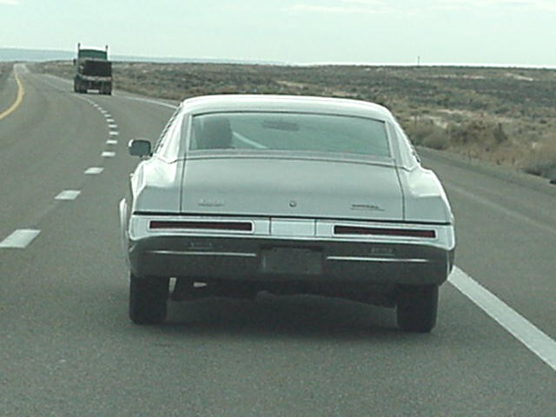
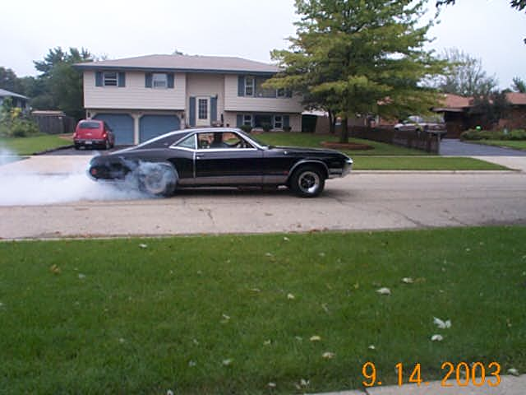

Two More pictures of the DeMik Brother’s Cars

World of Wheels Chris Gatch

We are looking for a few good cars! World of Wheels is right around the corner and we are looking for members who are willing to display their cars this year at our display. This will be the 10th year of the Chicagoland club and we want to bring out our cars to show off the kind of club we really are. Being a special anniversary year, we will have a treat for all the participating members of this year’s show! World of Wheels is being held this year at McCormick Place North on January 30th and February 1st.

Many people have express interest in this show - now is your chance to step forward and show off your cars. If you are interested please contact me before December 12th. We only have 12 spaces available this year for our display so once again if you have interest please let me know. Please send the applications to me and not to John Langston this year. This way I may go over the applications to make sure all our cars are placed together at the show. I will then personally deliver the information to John Langston himself to assure we will be together as a club. You can call me in the evening at (773) 776-4794 or email me at CGATCH@PORTER-ATH.COM and I will get back to you as soon as I can so that we can discuss further information at that time. Space is limited so call today!

Christmas Party – December 6, 2003
We’ve booked the same place as last year, the Brookfield VFW hall at 8844 West Ogden Avenue, Brookfield, IL. The party will run from 5-11 pm. The club will be providing the main dishes, and a competition will be held again for best appetizers, side dishes and desserts. Trophies and prizes will be awarded for these. This year we will have a D.J., Midnight Mike, and show videos of Nats from the past. We’ll award the race trophies, and raffle off some cool stuff again. This party is free for each club member and one guest. Non-members will be $5.00 each.

Midwest Buick Challenge – Paul Brelie
A fair weathered friend this year’s Midwest Buick Challenge was not. Weather forecasters predicted rain throughout the weekend, and unfortunately there were many who had taken that to heart. Those who threw caution to the wind and dared to disbelieve the forecast for that upcoming weekend had a wonderful time, and those who didn't unfortunately missed out on a lot of fun.
For those who made the journey on Friday night to watch the Street Car Chaos, the threat of inclement weather had forced the track to shut down. Those of us who remained at the hotel (Holiday Inn Express in Kentland) had a night of saying hello to old friends and the never ending bench racing series kept many of us outside well past even the local wooly worms curfew.
Saturday morning looked like it would be another cloudy overcast day with a threat of rain. People were slow to trickle in, but by midday the sound of cars making their way down the quarter mile was never ending. Besides the test and tune activities, there was a small number of venders selling their products, a car show that was being conducted and of course, one could always take a break and sit in the bleachers to watch some racing.
Saturday night’s festivities, at least for those who stayed in Kentland, consisted of a pizza fiesta at a local Italian eatery, and then another late night get-together at the south end of the parking lot. There were Buick enthusiasts from Illinois, Indiana, Wisconsin and even some traveling electricians from further west that participated in the night’s activities. The only thing that was missing from this year’s celebration was the corn, but that's another story in itself.
There was a Birthday celebration, table number racing (had to be there), discussions on the significance of the black wooly worm, and oh yea, lots of car talk. There were about 30 people who spent the better part of Saturday and the preceding evening with us who just wanted to have a good time, whether it rained or not. As I called an end to the nights festivities, it really didn't seem to matter if it would rain on Sundays race or not, because a good time was already had.
Sunday morning arrived with the rain predicted all weekend ending early. The area around the tent became a little soggy, and the track needed a bit of time to dry off before the racing started, but start it did. There was some concern in the tower that the days racing could be cut short, so the schedule was pushed up an hour, and this caused havoc in many a pit area. Some people were just arriving when the last call for test and tune rang through the loudspeakers, but like true sportsmen, everyone did the best they could with the situation at hand. I wish to personally thank all the racers who had the patience and dexterity to pull it off.
The list of winners and runner-ups is far too long to mention in this column, besides if you check the web site on occasion, the bracket winners were listed there. And although there were a few disgruntled racers on Sunday due to the accelerated start time, everybody had a great time doing whatever it was they did. As this race is held year after year, we, the volunteers, are getting more organized. Some of this organization may be through trial and error, but if you partake in the many of the events being held you must admit that it is almost like a regular day at the office. Thanks to Mark Holda for holding things together up in the tower. That is a relentless job to hold especially when you have as many brackets as we did. We can’t forget all the ladies back in the tent who did all the behind the scenes work that made the race chairmen’s jobs effortless. Loyd, as always, got involved in the staging lanes making sure people lined up correctly. I would also like to give a welcome to Wayne Smith from Morocco, one of our newest members, who went out of his way to help us. I just hope we return the favor in some way. There are just too many others to list but you know who you are, this event could not be done without you.
I think if there is anything I have learned, it would be not to listen to the weather forecast. This year we had two major events, one being the Midwest Challenge, and the other the Nats down in Bowling Green. Both had fewer participants because people backed off with the threat of rain. I drove down to Bowling Green in the pick-up truck because of that fact, and missed my car every day. Next year there will be nothing but sunshine and 70-degree weather for all events, at least that is how I am planning it. If it should rain, well I guess I will get a bit wet, but I will be doing it with a car club that is truly the best.
Let us keep Going Fast With Class!

Calling all Members for ideas for improving the Club
In December 1994 the remnants of the Illinois Chapter reinvented itself to become the Chicagoland Chapter. Therefore 2004 is our 10th Anniversary as a Club. As always we will be seeking ways to improve our club for our member’s benefit. Please take the time to fill out the survey that is part of this newsletter and send in. Your ideas are very important to the board.

Cruise News - Chris Gatch
Hello everyone!
Well the end of another year is already upon us. This was a fun and exciting year that was filled with many events and cruises. I just want to thank everyone that attended one or more of our events. It takes a lot of work to organize some of these events and we had pretty good club participation. I am looking forward to even more participation next year.
Here is a rundown of a few shows that were well attended by our club members. The mid summer show at Loren Buick in Glenview was well attended this year considering that it looked like it was going to rain all morning long. But it held out and we had a beautiful day. There were about 15 club members that attended this event with awards won by Steve Ledger, Bill Grupp and Terry Klemmer and myself who won nice trophies in our respective classes. This was fantastic for us as well as the club!
In between Loren and the MwBC we had a few more shows and cruises that we attended. First up was the Ettelson BOC show in Hodgkin's. This was the second year that we attended this as a club. There was a little confusion going on at this show but once the smoked cleared and we finished moving around it turned out to be a nice show. Brad Berger and Mike Fleischer were the big winners in the GS/GN class so congratulations go out to them. Frato’s cruise night was another nice cruise that attracted many of the northern club members. I guess there were about 7 members in attendance for this cruise and congrats to Shari for getting a trophy that evening with her GS. Thanks again Jack for helping set this event up for the club!
September & October brought about a few shows & cruises as well. The Midwest Challenge was well attended by all and the show attendance seemed to be up a little from last year. Here are the car show results:
Gran Sport Class
1st - John Schmidt - 71 GS Stage 1 Convertible
2nd - Shari Bonecutter - 70 GS 455
Turbo Regal Class
1st - Russ & Karen Ciesiolka - 86 GN
2nd - Karen Vaughn - 86 T-Type
General Buick
1st - Tim Goheen - 67 Riviera
2nd - Jim Brown - 72 Skylark
Buick Powered/Modified Class
1st - Chris & Anna Gatch - 87 GN
2nd - Tom & Debbie Jenkins - 72 GS
Congratulations to all and hope to see everyone there next year!
The final cruise of the year was at Mickey’s Gyros and this was a rather cool evening. There were a few club members that braved the cool weather that night to help close out the season. Thanks to everyone that showed. The second to last event was at the Cascade Drive-In. Unfortunately, I was unable to make this event but all I want to say is THANK YOU to everyone that showed up on this frigid evening. We did have an assortment of cars, which varied from a couple of GNs, a GS, and a GSX as well as a few other brands! Thanks again for coming out. We are going to make this event earlier in the year next summer to try and attract a few more cars as well as not looking and feeling like Eskimos this time!
The final show of the year was Marquardt. We had a record turnout for this show on a beautiful fall day. There were also quite a few club members that won awards that day. In the Modified class Don Hens took home first with his GN. In the Turbo class we had Paul Breile, Paul Vilser and I with our GN’s. Finally in the GS class there was Brad Berger with his GS Convertible, Mike Mullen with his GS 400 and Mike Fleischer with his GSX. We had about 18 club members there to support the show. Thanks to all for coming and congratulations to anyone that I might have forgot.
With the end of the year coming about that means only thing…planning next year’s schedule. I am already planning on having some of the same events again next year and am in the works for a few more. Remember that our first show will be the World of Wheels, which will celebrate our 10th year as a club together (this time around). If you think that you might be interested in showing your car please feel free to contact me. I would also like some input from our club members to what they would like us to do as a club next year. If anyone has any shows that they know of and would like to get them down on the clubs activities calendar please let me know well ahead of time so that we can work it in.
Well I think that everyone is probably already working on their cars for next year because it’s right around the corner and before you know it we will be racing and cruzin all over again! I would like to wish everyone a safe and happy holiday season and hope to see everyone again next year Going Fast With Class!

Please look at your mailing label
If it says January 1st 2004 on it, now is the time to renew. If you are going to a winter meeting you may simply reapply there. Otherwise send the enclosed application in, with your $20.00 to receive this fine newsletter.

Meandering Membership Memos - Shari
Hi, everyone! Here it is, the end of a very busy year! I thought that, as a club, we were going to cut back a little this year on events. But it didn’t seem like it, when you look back. Especially fall – you know that everyone wants to try to extend the car season just a little bit more. Well, I’m writing this on the Monday before Thanksgiving, and I think we have to say “uncle.” It’s in the 20’s and there are flurries out there. So I guess it’s time.
Paul wrote a most excellent article on the MWC, so I won’t repeat too much here. I just wanted to thank Barb, Mary, Carol and Linda for the tent help. We couldn’t be in business without you ladies. Mark, Loyd and Paul try their best to corral the racers, and keep everyone happy – tough job to do! But the work is appreciated! The Indiana chapter did their usual great job on the car show. I heard that there were a couple more cars this year – congrats! Both clubs did something different this year – we offered a cash people’s choice award. I’m pretty sure that we’ll do this again next year. Just think – you could win cash for your car in 2004! New member Wayne Smith had just joined the club that weekend, but showed what makes our Buick community so great. Someone lost their keys, and Wayne went back and forth between home and the track with tools and such to try to help. What a great guy!
Chris also did a great article on the shows and cruises, so again I have no need to repeat. Just a big thank you for your participation! Nothing pleases this board more than to see a big bunch of Buicks! (Say that really fast 5 times!)
This year a group of us went to or first Cordova for their B-O-P race. It was the first time for our little group, so we made plans to spend the weekend in Clinton, Iowa nearby. We didn’t realize that it was only about 2 hours away! The track at Cordova is great – ask those who actually raced. The rest of us liked it because there’s a sheltered pavilion to sit in, offering shade, where you can kind of see the track. There were not a huge group of cars there, like you have at Great Lakes B-O-P, so you could get a lot of runs in. We’ll be going back again in 2004, and also staying the weekend – it’s a nice get-away.
Which speaking of racing, we had a few more races this year. Again, we pretty much had the same people at them, but that’s o.k. Our last race at Byron the end of October had a lot of our Wisconsin members’ show up. It was great to see all of you. We pretty much froze at this event, but the cars loved it!
Now we’re marching towards the Xmas party, our last event of the year. Please, please let me know if you’re coming! I really need to know how much food to order. We’re going to have Midnight Mike d.j.-ing for us this year, and you should be prepared to sing a little. I’ve been buying some awesome raffle prizes – I hope you’ll like them. This year, the raffle money will go to a charity again, like Drag Racing Association for Women, which has a fund for the families of injured drag racers. Last year, we raised $500. We’ll see what we do this year!
Membership news - Bad news, first. One of our advertisers, Bob Bratcher, lost his brother Jim to a motorcycle accident. Those of you that know Bob knew his brother, too. Jim was a co-owner in the Midas shops. Joe Rivecco lost his cousin Andre in an accident, also. Sudden losses are terribly hard on the family. Carl Creque Jr. lost his father, Carl Sr. after an illness, and Wayne Bacher lost his father George, also after an illness. All of our prayers go out to you folks.
Baby news – Brad and Suzie Crowe had an addition to their family. Their son, Dylan, was born November 5th. I understand that Jason Rickey and his wife are due any day now, with their first child. And I think that’s all I know about.
New and returning members – We had a bunch! Welcome back to Chris DeMik, New Lenox, IL; Sean Doggett, Ridgefarm, IL; Tom Osec, Chicago, IL; Roland Quintanilla, East Chicago, IN; Kelly Rogers, Chicago, IL; Chip Short, Peoria, IL; John Tubbs, Green Bay, WI. And a hearty welcome goes to the following new members: Beth and Dana Andrews, Skokie, IL; Anthony, DiNella, Oakbrook Terrace, IL; Bruce and Shirley Durband, Burlington, WI; Larry Lewin, Chicago, IL; Hector Martinez, Chicago, IL; Scott Mazies, Richton Park, IL; Lloyd McCabe, Waupun, WI; Jo Puthusseril, Morton Grove, IL; Richard Sanks, Zion, IL; and Wayne Smith, Morocco, IN. I really hope to see you all at some of our events. Thanks for joining!
A majority of you have your membership due in January. There is an application in here somewhere for you to fill out and mail in. If your information has changed, you could use the form for that, also. If your email address has changed, please drop us a line and inform us of the new one. Our email addresses are inside the front cover.
We’ve also included a survey for you all to fill out. We’d really like your opinion on things, so please take some time to fill this out. You can either mail it to us at 4010 Raymond Avenue, Brookfield, IL 60513 or you could drop it off at a meeting.
So in closing, Loyd and I wish you and yours a great holiday season. Enjoy and stay safe!

“Wagon Rick” Sliwinski owner of Precision Engine and Machine, Inc will have a booth at the 2004 World Drag Expo on January 17th or 18th. Rick invites everyone to stop by and say hello. Rick’s # 847-903-9585
Pheasant Run Resort & Spa
4051 East Main Street / St. Charles, IL
Call 800.4.PHEASANT or www.pheasantrun.com/
Classified Ads
1967 Riveria
Show car winner at Midwest Buick Challenge. Midnight blue with a black interior and torque thrust 2 wheels. Powered by an Evans racing/AMP built 455 motor. Asking $13000. Call Tim Goheen @ 630-289-7232 or E-mail: timonator@wowway.com
72 GS 455 (Sloan documented)
Fresh motor with 6000 miles Chassis Dyno @ 410 h.p. Fresh transmission w/ shift kit and 3000 rpm stall torque converter. Fresh 342 posi w/ no hop bars, stabilizer bar, boxed arms and air bags. Front & rear suspensions rebuilt with springs and bushings. BF Goodrich tires on 15" wheels. Lots of other goodies Asking $ 15.000 contact Bruce Durband at 866 273- 4227 or E-mail ftc_carpentry@yahoo.com
1987 Buick WE4
With 45,000 miles purchased March 2002 from original owner who used as a summer driver. Options include: Astroroof, power windows-locks-antenna, Concert Sound II, rear defrost, cruise,
Modifications include: Walbro GS307 w/ hotwire, RJC power plate, ATR 2.5" downpipe, Hooker dual 2.5" exhaust, new KYB shocks, drive shaft loop, vacuum master cylinder, boxed rear lower control arms. Just had the rear main seal and valve cover gaskets done at Pro Trac Turbo Specialties. Price $11,000 firm contact Glen Reyelts – E-mail: DCVING6@aol.com
87 Buick Turbo Regal
Gold, T-tops, 44,000 miles, Tan cloth buckets, mint condition. First $12,500 takes it home
K. Diane Lanter – Battle Creek, MI - 269-966-2454
If seriously interested contact before 9PM any day of the week
G. S. Collectibles 1/18th scale - 1970 Buick (GS) Gran Sport Stage 1 Convertibles in Diplomat Blue, Glacier White or Regal Black. $109.00 + $8.00 for shipping with additional car’s shipping $2.00. Buy all 3 cars (Black, Blue, White) $99.00 each
1/18th Scale - 1987 Buick Gnx (X-Ray) now only $39.00 + $8.00 Shipping
Call 773-968-5015 or check out http://buicktoys.com/

For 1970 to 72 Skylark and GS Parts
Contact Fred Vaughn who restores these cars by dismantling others. Has three complete cars and many parts in Morris, IL. Phone # 815-357-1576
Johnny Gribble’s world of 1970 to 72 GS Parts
Complete 455 Engine 500
455 Timing Cover 300
455 Fly wheel 30
Pair of 455 cylinder heads (uncut) 200
Pair of 455 cylinder heads (shaved) 175
Quadrajet for 455 150
Aluminum intake for 455 75
1970 - 72 Rear quarter panel 250
Turbo 400 short shaft ready to install 500
Turbo 400 short shaft core 250
1970 - 72 Passenger side fender 200
71 GS Hood molding piece 250
1968 thru 72 Bucket Seats 150
1968 thru 72 Dash Pad 100
1972 Riveria white seats front and back 500
Complete 1986 Regal (blown head gasket) 1600
Contact Johnny at 847-451-1712
Buick RaceDay 2004 is Friday, April 30th, test and tune, gambler’s race; Saturday, May 1st, show at Arbys; and Sunday May 2nd. Flyer is at http://www.mi-Buicks.com/Norwalk/Norw2004_files/slide0001.htm.
Excerpts from Michigan Chapter’s Newsletter:
Buick RaceDay at Norwalk Raceway in May 2003 was the ‘Ultimate Buick Experience” with the “Fastest Buicks in the World”. The Thursday test and tune sponsored by the Buick Performance Group was the opportunity got to work some bugs out of the cars. On Friday we didn’t get a lot of racing in, but we were able to get the Gambler’s race completed with Doug Hecker taking the win, running low 9s with his new engine! Congratulations! After the racing we enjoyed a chicken and rib dinner at the track which was awesome!
Saturday morning, brought the sun and wind, for the car show, with a record number of outstanding Buicks and vendors in attendance. Thanks to Norma, from Arby’s for her great hospitality and support for the show. Saturday night we ventured to Sandusky for a buffet meal at the Holidome. After dinner we were able to listen to Dick Bradshaw from Bulldog Performance in Indianapolis, speak about the new V8 block
Sunday morning, Norwalk Raceway Park turned into Buickland. The Quick 16 bump spot for the 1st round was 9.66! Everyone was in awe. Second Round brought it down to 9.545, more awe! There were 9 V8s and 7 V6s in the running. Stan Zerucha took the win for the 2nd year in row!
This is another great event near Chicagoland.

