The long and short of Big Block Buick water pumps

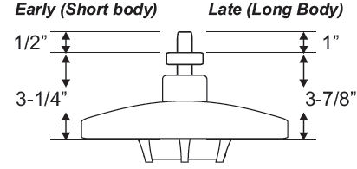
Dimensions of Big Block Buick water pumps factored from gasket surface.
Difference of pulley placement of short vs long neck water pump is 5/8 inch

Buick 455 Water Pumps
by Scott Moody and Mark DeConti
In doing a roundup of all the aftermarket water pump part numbers I could find, I came across very some interesting results. Looking at the pictures off the websites (where available) I eventually noticed differences in the impellers. Some impeller blades are long and go all the way to the edge of the impeller disc. Some are shorter and don't reach the edge. While others are medium in length. Does this have an effect on cooling? Maybe. I would like my blades to be full length. How about impeller blade depth? Some look shallower and some look deeper, it's hard to tell just from pictures.
Here they are arranged by tall or short neck. The short ones are for 70 and earlier (I think) and the tall ones are for 71 and newer (I think). If this is incorrect please let me know. The info presented (where available) is: manufacturer name, new or rebuilt, part number, price, and impeller blade length.
Short neck, early models:  A1 Cardone new 5513141 $60 med  A1 Cardone reman 58111 $25 long  AC Delco new 252295 $68  Airtex new AW821 $55  ASC indust. new WP384 $59  Carter new FP1400 $87 med  GMB new 130821 $64 short  Master Parts new CP821 $64  NAPA new NWP55821 $67 short  Bosch 98016  Eastern 181080  Borg Warner P494  Parts Master 3-384  Tall neck, later models:  A1 Cardone new 5513112 $28 long  A1 Cardone reman 58113 $15 short  Ac Delco new 252122 $61  Airtex new AW1045 $49  ASC indust. new WP451 $46  Carter new FP1457 $80 long  GMB new 1301400 long  Master Parts CP1045  NAPA new NWP551045 $62 long  Borg Warner P611  Bosch 98031  Eastern 18-318  Parts MAster 3-451 | 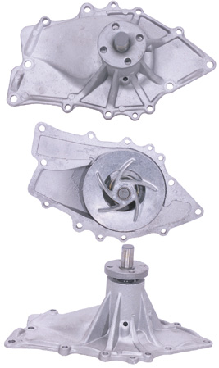
Prices are from: rockauto.com, napaonline.com. advanceauto.com, autozone.com, oreilly.com .
Cross reference information was taken from ASC industries and Airtex Products websites.
Note the commonality between different manufacturer's part numbers.
All pictures that I found so far were of 5-blade cast impellers, not stamped nor 6-blade.
It's interesting that the only short neck pump that I can confirm has long blades is the reman cardone unit, 58111. The later pumps have more long blade units.
 | 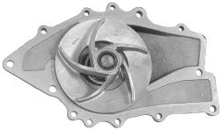
Five short impeller blades | Five long impeller blades
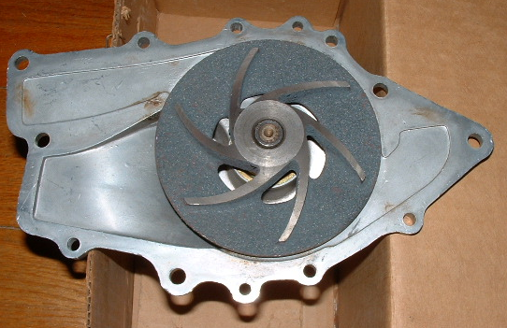
Example of a 6 blade impeller:

Photo courtesy of Dave Steele

Pump Style |  | Pulley Ratio | Pulley Sizes
Five blade | A/C (HD) | 1.311 | Balancer Pulley (7 3/8") diameter much larger as  Water pump pulley (5 5/8")  Not sure why some pumps have longer blades.
Six blade | NON A/C | 0.926 | Balancer Pulley (6 1/4") almost the same as the  Water pump pulley (6 3/4")
The NOS correct part number pump for a non A/C application 67 BBB has 6 blades. New or NOS A/C application pumps sourced during the last 30+ years have been 5 blade.
Stage 1 cars came with heavy duty cooling which included the clutch fan, 3 row radiator and the A/C pulleys with a 5 blade water pump. A/C equipped 455 engines also came equipped with heavy duty cooling systems.
In 1971 the water pump length became longer and the pulleys changed part numbers. The majority for 71 on up cars had A/C. However non A/C still used the 67-70 6 blade pump with different pulleys.
Using A/C pulleys on a 6 blade will flow coolant too fast, and using non A/C ones with the 5 blade pump can cause overheating at slow speed or idle.
I tried mixing types over the years and had these problems.
My 2 cents on this,
Mark DeConti

Water pump & Balancer pulleys
The first breakdown is by year. 67-70 used the short length water pump (3 1/4 inch from pulley mount flange to gasket surface) and 71-76 used the long length water pump (3 7/8 inch from pulley mount flange to gasket surface). The part numbers for Water Pump Pulley and Balancer Pulleys are as follows
 | Cooling | Pulley | Water Pump Pulley | Balancer Pulley
Year | System | Ratio | Part # / Diameter / Depth | Part # / Diameter / # Grooves
67-70  (Short) | Std | 0.926 | 1375141 / 6 3/4" / 2-1/8" | 1375142 / 6 1/4" / two
67-70  (Short) | HD | 1.311 | 1375146 / 5 5/8" / 2-1/8" | 1375143 / 7 3/8" / three *
71-73  (Long) | Std | 1.087 | 1238156 / 5 3/4" / 2-7/8" | 1235779 / 6 1/4" / two *
71-73  (Long) | HD | 1.261 | 1235778 / 5 3/4" / 2-7/8" | 1235777 / 7 1/4" / three *
Note: Balancer pulleys marked * have a 5 3/4“ power steering groove
Std – Non A/C equipped cars / HD – A/C equipped or Stage 1 cars
Water pump pulley: Std – single groove / HD - double groove

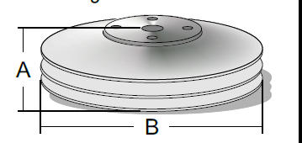

TA Performance Billet Pulleys Available
 | A | B
Underdrive, short | 2-1/8 | 5-7/8 | 400-430-455
Underdrive, long | 2-7/8 | 5-7/8 | 400-430-455
Overdrive, short | 2-1/8 | 5-3/8 | 400-430-455
Overdrive, long | 2-7/8 | 5-3/8 | 400-430-455
“Short” Pulleys replace OE P/N 1375146 5 5/8" two groove Standard drive
Double groove A/C pulleys
1970 455 Water pump pulley, for short nose pump. w/air 1375146 and the diameter 5 5/8"
1971 455 Water pump pulley for long nose pump. Part #1235778
1972 GS. Water pump pulley 1235778 and the diameter 5 3/4" two groove.

